Keeping Yourself Safe From Exploitation
Do Now Work:
Link the words to their meanings:
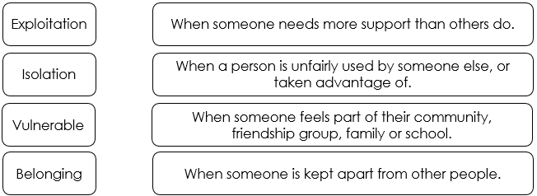
Gemma’s Story
Gemma was 15 when she met Jay, who was 17, at a party.
Gemma didn’t get on with her Mum and they often argued. She didn’t enjoy school. Jay became the only person she cared about.
Jay gave Gemma nice presents like clothes, jewellery and a new phone. He gave her money when she needed it. He was cool, and he drove a nice car. He told her he loved her.
Jay said he didn’t like Gemma’s friends, and that her Mum was trying to split them up, so she stopped being friends with them and stopped going home. She began to rely totally on Jay.
Gemma would party with Jay’s friends. Jay and his friends would give Gemma alcohol and drugs. For free…?
Jay told Gemma that he needed to pay his friends back for the alcohol, drugs and money. She could do this by having sex with them. Sometimes she was so drunk or high that she didn’t even know if she’d had sex, or with who.
Task:
Read the case study and answer the questions in full sentences:
- What made Gemma vulnerable? (e.g. “Gemma was vulnerable because…”)
- How did Jay make her feel that she “belonged”?
- How did Jay isolate her further?
- How did Jay persuade her to have sex with his friends?
- How did Jay exploit her?
- What signs might you have spotted if you were Gemma’s friend?
- If you were Gemma’s friend, how could you have helped her?
Challenge: What do both of these stories have in common? What is different about them?
Extension: Imagine you are Gemma’s friend. Write her a letter to persuade her that she is being exploited.

