DSL Supervision Process guidance
Purpose of supervision is to reach a balance between personal support and guidance, managerial review and case management analysis encouraging reflection upon good practice. Supervisory sessions need not cover all aspects of supervision simultaneously or in the same manner. Vital however, is a planned, structured approach to delivery and a sound supervisor/ supervisee relationship supported by a supervisory “contract” (example below). Supervision conversations should be solution focused and mirror use of open questioning in Early Help practice. EARS This document is intended as guidance for you to adapt to your setting.

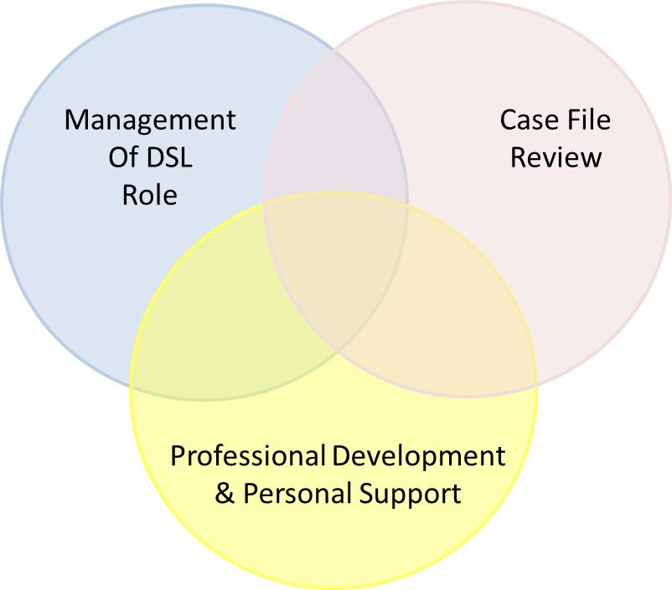
For supervision training courses relating to this model please contact;
Services for Education S4E

Management of DSL Role – developing a robust Safeguarding System in your setting
`Inspectors should consider how well leaders and managers….have created a culture of vigilance and appropriate action is taken for children or learners who need extra help or who may be suffering or likely to suffer harm`. OFSTED 2019

Use existing reports and school assessment tools e.g. OFSTED reports, School improvement partner reports, Section 175 self-assessment as a basis for analysis.

Example areas to select | Supporting evidence | Tools to support development
Compliance with policies and procedures | Birmingham Safeguarding Children Partnership S175  Education Safeguarding system and practice review | Birmingham Safeguarding Children Partnership S175 action plan  Education Safeguarding system and practice review action plan  Education Safeguarding webpage
Trends for staff raising concerns | CPOMS/ My Concern | Analysis by year groups, departments etc
Trends across cohort / community | Police School Panels | Public health local area health profiles
Profile of Early Help intervention | Numbers of Early Help assessments/ plans completed | Quality assurance reports from Education Safeguarding team  Payment by results guidance
Joined up working across school | Joint approaches, interventions DSLs , behaviour leads, mental health leads, SENCO | Early Help Assessments/ plans
Part time tables / attendance | Are any children on reduced or part time timetables? | Are these granted in very exceptional circumstances? Are plans time limited?
Managing Challenging Behaviour/ risk assessments | Behaviour audit survey for schools inspectors ( Creating a culture Tom Bennett) | DfE publications  Mental health and behaviour in schools  Independent report - Behaviour in schools

Case Reviews
`Clear procedures in place, effective use of risk assessment, working in partnership`
OFSTED 2019

Types of discussions | Method | Support
Review of Children with a Safeguarding Vulnerability | 1:1/ group | Wider school staff e.g. attendance officer, SENCO, behaviour lead
Outcomes for requests for support / referrals to FTB etc. | 1:1/ group | CASS Education team 0121 303 2291/ request support with CASS enquiries
Review of Early Help Assessments/ plans/ outcomes | 1:1/ group | Request quality assurance for specific cases – Education Safeguarding  educationsafeguarding@birmingham.gov.uk
Identification of additional services/ interventions for families | 1:1/ group | Family support team duty lines  The Waiting Room  Google searches
When cases get “stuck” | 1:1/ group – action learning sets | CASS Education team 0121 303 2291  Action learning set training – S4E

Professional Development Whole Schools and personal

Conversation starters
What would your schools safeguarding culture be like if your values were being lived all day, every day? | What are you looking to develop? | How will you support individuals/ be supported to embrace new ways of working? How will you resource this?
Which groups of people are key to delivering excellence in safeguarding in your school? | Who can help you?  What can you do? | Describe your best day at work.  What/ who helps you to function at your best?
What behaviours do you see that promote excellence? How can desired behaviours be developed across other areas? | What are your…?  - Development ideas  - Vision and values  - Long term goals | What are the repeating patterns of your work life?  ( what do you do well and find yourself repeating in different situations)

