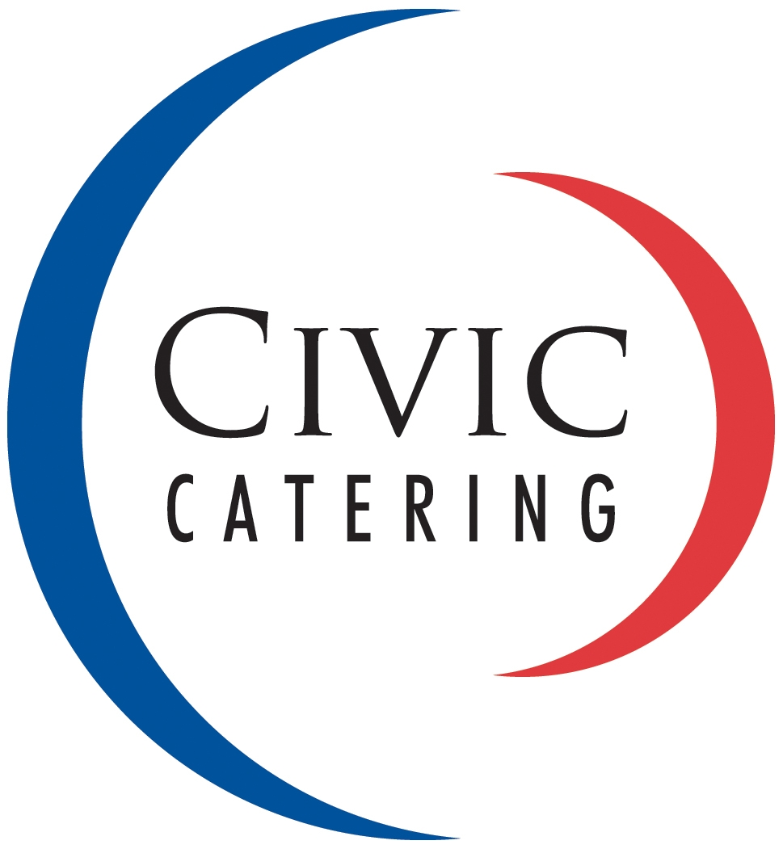
e civic.catering@birmingham.gov.uk
t 0121 303 2050

 | DATE OF EVENT
 | TIME REQUIRED
 | CONTACT NAME
 | TEL. NO
DELIVERY ADDRESS
(BUILDING NAME AND ROOM NUMBER)
 | INVOICE ADDRESS (EXTERNAL)
 | BUDGET CODE (INTERNAL)
 | SERVICE REQUIRED  (MAY INCUR AN ADDITIONAL CHARGE) | SELF SERVICE / SERVED
 | DISPOSABLES OR CROCKERY  (CHARGES WILL APPLY FOR CROCKERY OUTSIDE THE COUNCIL HOUSE) | DISPOSABLES / CROCKERY
 | NAME OF MEETING
 | NOTES / SPECIFIC INSTRUCTION REGARDING DELIVERY
 | DATE BOOKING TAKEN
 | SIGNATURE
 | CATERING REQUIREMENTS | TIME | NUMBERS/QTY | SPECIAL DIETS /  ADDITIONAL INFORMATION
CATERING ORDER

FOR OUTSIDE CATERING DELIVERIES ONLY
TIME ARRIVED:

CROCKERY TO BE COLLECTED AT  (IF APPLICABLE) | DATE TIME
COMMENTS:
(EG. JUICE/WATER/WINE RETURNED)
TIME OF DELIVERY: | _ _ / _ _
CUSTOMER’S SIGNATURE: | PRINT NAME:
DELIVERY PERSON’S SIGNATURE: | PRINT NAME:

