About Us
Looking for an inspirational venue for staff training? Look no further.
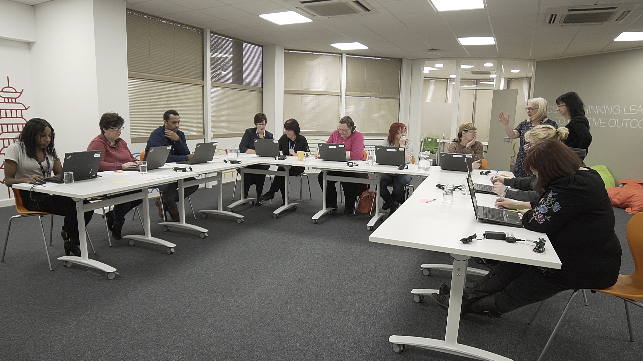
Situated in the heart of Birmingham, your brand new Learning and Development Centre is a state of the art venue designed to inspire, motivate and educate. We are an accredited Qualsafe Awards Centre - our catering-industry focussed legislative training courses are formally recognised by government agency Ofqual, which means peace of mind for you. Training is delivered by Cityserve, the multi-award winning Foodservice Division of Birmingham City Council and one of the region’s largest and most respected employers. As a civic-organisation, we have no shareholders and our purpose is to provide an excellent service and its values.
Hospitality
Refreshments and a light lunch are included during training. If you are booking for a large group, you are able to upgrade your hospitality package. Please provide us with dietary requirements upon booking.
Getting Here
By Car
There is a pay and display parking available at Millennium Point, Howe Street, Birmingham B4 7AP.
By Bus
Both the No. 66 and 66A buses stop outside Cityserve Head Office.

Booking Process
To book, please contact CityserveTraining@birmingham.gov.uk or 07860907022.
Training Courses
Course | Costs (Per Person) | Duration | Dates 2018
Food Safety Level 2 | £85 | 1 day
  Wednesday 25th April
  Wednesday 20th June
  Tuesday 17th July
  Wednesday 5th September
  Tuesday 18th September
  Tuesday 25th September
First Aid at Work | £170 | 3 days
  Monday 4th - Wednesday 6th June
  Monday 2nd - Wednesday 4th July
  Monday 10th - Wednesday 12th September
  Monday 5th - Wednesday 7th November
Emergency First Aid | £80 | 1 day
  Thursday 10th May
  Thursday 14th June
  Thursday 28th June
  Thursday 1st November
First Aid Refresher | £125 | 2 days
  Thursday 21st - Friday 22nd June
  Wednesday 11th - Thursday 12th July
  Thursday 6th - Friday 7th September
  Thursday 20th - Friday 21st September
  Thursday 18th - Friday 9th October
Manual Handling | £30 | ½ day
  Wednesday 16th May
  Tuesday 19th June
  Wednesday 26th September
  Wednesday 28th November
Fire Safety Awareness | £30 | ½ day | Tuesday 27th November
Health and Safety Level 2 | £85 | 1 day
  Friday 27th April
  Tuesday 8th May
  Tuesday 15th May
  Tuesday 12th June
  Wednesday 19th September
  Thursday 11th October
  Tuesday 16th October
  Thursday 15th November
  Thursday 20th November

If you cannot find the course or dates you are looking for, please do not hesitate to get in touch.

